Digital Program Charter
Project Management Office

Name
December 6, 2019
Contents
1.0 Charter Purpose 3
2.0 Project Overview and Objectives 3
3.0 Scope 3
In-Scope 3
Out-of-Scope 3
4.0 Benefits and Costs 3
Benefits 3
Financial Cost Benefit Analysis 4
5.0 Key Success Factors 4
6.0 Project Completion Criteria 4
7.0 Constraints and Dependencies 5
8.0 Milestone Timeline 5
9.0 Stakeholders 5
10.0 Risk Summary 5
11.0 Project Governance 6
Project Structure 6
Project Steering Committee <remove if not applicable> 6
Project Management Plan 6
Project Communications <update table below as applicable> 6
12.0 Approvals 8

Charter Purpose
The purpose of the Project Charter is to formalize the existence of the project and to provide the Project Manager with the authority to secure resources and the funding to deliver the project scope as defined.

Program Overview and Objectives

The key goal of this program is to digitize the Account Opening processes and be a disrupter in offering unique Online Banking platform products and services for Small Business Owners.

Business Objectives and Strategic Alignment
The Digital program supports the following key strategic objectives:
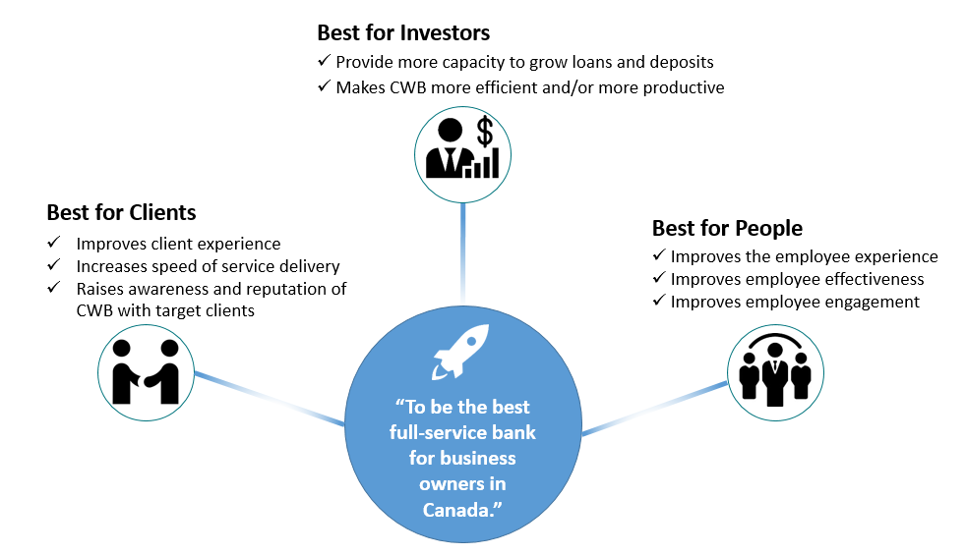
Best for Investors:
- Attracting new clients which will increase loans and deposits will benefit investors.
- Reducing manual efforts that are currently required to open new accounts will improve efficiency and productivity.
Best for Clients:
- The modern and distinct products that will be delivered by the Digital Program will improve client experience though improving the functionality of the online systems, and offering clients tools they don’t have access to elsewhere.
- Digital Account Opening will offer retail and small business clients a much faster way to open a new account remotely, which will benefits prospective new clients who are outside of CWB’s current geographic branch footprint.
Best for People:
- Reducing manual efforts required by CWB staff will improve the employee experience and allow them to focus on more value-add activities.
- Staff are clients of the bank, and will benefit from the improved experience that will be delivered by the retail changes in the Digital Program, and in particular the enhancements to personal online banking.

Scope

In-Scope
The Digital Program will deliver the following solutions as program phases, using a core program team of shared resources:

• Motive Digital Account Opening
• Personal Digital Account Opening
• Branch Personal Digital Account Opening
• Small Business Banking Platform (Including Digital Account Opening for Small Business)
• Branch Small Business Digital Account Opening
• Corporate Digital Banking Platform
• Personal Digital Banking Platform
• Motive Lending

The detailed scope and business requirements for each of the project phases listed above will be defined at the start of each phase.

Out-of-Scope
The following items are considered to be out of scope of this project:
Changes to current products such as CWBdirect online banking, CWBdirect Business Online Banking and Cash Management products such as CAFT, Remote Deposit Capture and CWB Wires, unless otherwise defined in the phase scope statements.

Benefits and Costs
Benefits will be documented in detail for each project phase of the Digital program.
Delivering the scope of the project is expected to deliver tangible and intangible benefits. These will be tracked centrally and the results will be reported to PSC after the implementation. More information is available in the PMO Reportable Benefit Guideline.

Benefits
[Refer to the following examples to define project benefits. For a complete list of examples, refer to the PMO Reportable Benefit Guideline and Benefit Realization Report Tracker.] NOTE: remove this text from final version.

Benefit Summary | Tangible / Intangible | Key Organization Goals | Target Metric to be Achieved | Report Date on Target Metric | Benefit Owner
The Viking – ECN Acquisition -  Strategically increase geographic mix | Tangible | Diversifies our presence geographically | Western Canada: 25%  Ontario: 55%  Quebec: 11%  Maritimes: 9% | Immediate realization upon closing transaction | Stephen Murphy
Western Union Wires – New Generation  CWB will activate 1,000 clients in 2017 | Tangible | Grows our number of full-service clients | 1,000 clients ` | 12 months post implementation | Jeff Wright
NHA Mortgages Backed Securities -  Introduction of a competitive “A” mortgage product to drive incremental growth to | Tangible | Grows general commercial loans | Exceed Optimum Mortgage’s growth goal of 21% in fiscal 2017/2018. This will be measured by calculation of overall full year growth at fiscal year-end 2018 (2016 vs 2017 and 2017 vs 2018) | 12 months post implementation | Lester Shore
 | Choose an item. | Choose an item.

Financial Cost Benefit Analysis
The following is a summary of the Project cost benefit analysis. Full details are available in the PMO Cost Benefit Analysis spreadsheet on the project SharePoint.
The FY20 budget for the Digital Program will come from:
Source | Amount
Capital | $3,600,000
NIE | $3,400,000
TOTAL | $7,000,000
Measure | Result | CAP/NIE | Comment
Implementation Cost | $
Annual On-going Cost Summary | $
Additional Revenue & Cost Savings | $
ROI | %
Payback Period | Years

Key Success Factors
In order for the Digital Program to be successful the following conditions must exist:
- Resources: The Digital Program will require the involvement of several teams and resources, some of which need to be dedicated to the program full time. Subject Matter Experts must have a specific level of knowledge and experience and must be available at specific times during the program.
- Leadership: To manage the business process review, leaders who understand the solution and the impacts of change will be needed at all levels from executive to administrative. Executive Sponsors and Program Owners must provide visible, demonstrable and sustained endorsement.
- Priorities: The Digital Program must be regarded as a high-level priority. Conflicts between the Digital Program and other projects or operational work activities may impact the success of the Digital Program.
- Effective Decision Making: The decision making structure must be agile, accessible and responsive to the complex needs of the Digital Program. Decisions must be made in a timely manner and in the clear context of enterprise level goals and objectives.
- Communications: Communications is the lifeline of complex change. Sustained and focused communication to all stakeholders throughout the Digital Program, but in particular ensuring alignment of all of the vendors is critical to the success of the design, architecture and builds, to be reflected in the end-to-end integration testing, deployment and then sustainment.
- Methodology: CWB and the Digital vendors must find a way to align various methodologies, from waterfall to agile, in order to reliably deliver the business requirements defined.
- Sustainment: There must be resources allocated to sustainment of solutions beyond project closure or operational implementation.
- Compliance: Continual engagement with Regulatory Compliance must take place to ensure that all solutions are compliant with all regulations for consumer protection and fraud protection. This will mitigate significant risks to the project success as well as to CWB’s reputation and bottom line.
- Internal Guidelines: Adherence to the PMO Guiding Principles

Project Completion Criteria
The project has reached completion when:
- <List the specific criteria that determine when this project is complete, including the defined stabilization period assumed before the project is considered in Sustainment.>

Constraints and Dependencies
- <List time and technical constraints and dependencies including other projects, resources, operational initiatives, external parties, etc.>

Milestone Timeline
The following are the major program milestones and timelines identified at this time. As the program planning moves forward and the schedule is developed checkpoints will be established to confirm the milestones and their target completion dates.
Milestone | Activities | Target Completion Date
Program Initiation | Establish detailed program scope  Identify key stakeholders  Identify program benefits  Preliminary risk assessment  Develop Program Charter  Develop high level resource plan  Establish program governance | November 29, 2019
Digital Account Opening Planning | Identify detailed scope and Business Requirements  Develop detailed schedule  Develop detailed resource plan  Program kickoff  Create budget tracking  Develop Program Management Plan | January 10, 2020
Digital Account Opening Execution | Confirm detailed design and architecture  Complete development and unit testing  Execute end-to-end System Integration Testing  Plan and execute User Acceptance Testing  Conduct Pilot for Motive friends and family  Launch Motive DAO to the public  Launch Personal DAO | November 1, 2020

<Insert timeline diagram.>

Stakeholders
The Digital Program is a complex undertaking that impacts numerous and diverse groups of stakeholders. The following table represents the primary Stakeholder groups that will play a continual role throughput the Program. A detailed NI-RAP will be completed for each project phase to identify additional Stakeholders for engagement.
Stakeholder Group | Role on Project | Level of Program Engagement  (H\M\L) | Level of Operational Impact (H/M/L)
Banking Operations | Program Delivery | M | L
Branches/Regional Management | Program Delivery | M | L
Branch Staff | SME / UAT Support | L | M
Client Solutions | Program Governance & Delivery | H | H
Corporate Communications | Program Delivery | M | L
Information Services | Program Governance & Delivery | H | M
Motive Financial | Program Delivery | H | H
Organizational Change Management | Program Delivery | H | L
Program Management Office | Program Governance & Delivery | H | L
Regulatory Compliance | Program Delivery | M | M
Based on the output of the New Initiative / Change Risk Assessment Process (NI-RAP) <insert link to Project NI-RAP>, the Stakeholder groups that will be engaged to deliver the scope of the project as well as those that will be impacted post implementation have been identified and documentedin the <insert link to Project Stakeholder Register>. The following is a summary of the Stakeholder groups impacted during the project and post project implementation:

Stakeholder Groups with High Impact During Project: | <list Stakeholder Groups separated by comma>
Stakeholder Groups with Low to Medium Impact During Project: | <list Stakeholder Groups separated by comma>
Stakeholder Groups with High Impact Post Project Implementation: | <list Stakeholder Groups separated by comma>
Stakeholder Groups with Low to Medium Impact Post Project Implementation: | <list Stakeholder Groups separated by comma>

Risk Summary
The following high level risks identify events that could prevent the full realization of the project benefits. The Risk Likelihood and Risk Impact of each risk has been identified for both the initial view, where no controls or other mitigating factors are applied, as well as the residual view that remains after controls are applied. These risks, and new risks identified as the project progresses, will be tracked using the PMO’s Project Management system. They will be reviewed and updated regularly with the Project Owner, Executive Sponsor, and Steering Committee (if applicable).

Risk Category & Details | Initial View |  | General Mitigation Strategy | Residual View
Risk Category & Details | Probability | Impact | General Mitigation Strategy | Probability | Impact
 |  |  |  | L | H
 |  |  |  | L | M

Project Governance

Program Structure
The following Organizational Chart illustrates the reporting structure for the project roles, which are described in <insert link to Project Roles and Responsibilities>.

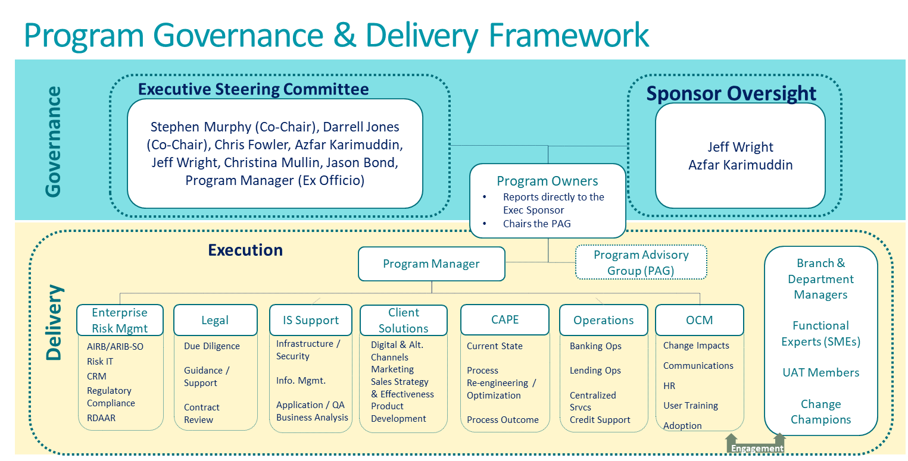

Program Steering Committee

A Project Steering Committee responsible for strategic decision making, guidance and general oversight of the project has been established. The structure, roles and responsibilities of the Project Steering Committee are documented in the <Project> Steering Committee - Terms of Reference <insert link to Project-specific Terms of Reference for Project Steering Committee>.

Program Management Plan
This Project will follow the project management processes established by the PMO as defined in the <insert link to Project Management Plan>. Exceptions to this plan will be added to this section as required for review and approval as part of the approval of this Project Charter.

Describe the Exception | Reason for the Exception

Program Communications
Project communications will be formalized through key project management meetings and the distribution of key project management deliverables. By approving this Charter, the Executive Sponsor and Project Owner commit time to the following project management meetings identified in the table below to ensure smooth delivery of the project. Descriptions of the key project management deliverables and meetings are available in <insert hyperlink to Project Management Communications - Meetings and Deliverables>.
Meetings:
Weekly Project Owner Meeting – 30 min - Monday
Weekly CWB Program Team Meeting – 30 min - Tuesday
Daily Stand Ups – Core team – morning – 15 min – Each Day
Vendor Meetings – Weekly (need to determine 30 min each vendor or combined) - Thursday
Program Monthly Risk/Dependency Meetings
(Frequency?) Executive Steering Committee Meeting – Nov 18 (Monday) Next Meeting (clarify what is needed)
Validate process information needs to feed up into this report and how far in advance material to be provided

Program Status Reporting
Provided on Friday for Project Owner Review on Monday. Distributed to Team end of day on Monday for review on Tuesday. Feeds into Vendor meetings on Thursday (sharing of our status/their status a well).
Propose to Vendors to use the CWB reporting status template to make amalgamation easier.
Participants  Meeting Name | Exec Sponsor | Steering Committee | Project Owner | Project Manager | Project Team | Vendor | PMO | Frequency
Kickoff |  |  |  |  |  |  |  | One Time
Executive Steering Committee |  |  |  |  |  |  |  | Monthly
Risk Review |  |  |  |  |  |  |  | Monthly
Executive Sponsor Update |  |  |  |  |  |  |  | Bi-Weekly
Project Owner Status |  |  |  |  |  |  |  | Weekly
Team Status |  |  |  |  |  |  |  | Weekly
Partner (Vendor) Status |  |  |  |  |  |  |  | Weekly
Monthly Project Status |  |  |  |  |  |  |  | Monthly
PMO Oversight (1:1) |  |  |  |  |  |  |  | Weekly

Approvals
Digital or hard copy sign-off is required from the following to proceed:
<Name, Title>  Executive Sponsor |  | Digital Approval  (Double Click and select ‘checked’ under Default) |  | Date
<Name, Title>  Project Owner |  | Digital Approval  (Double Click and select ‘checked’ under Default) |  | Date
<Name, Title>  AVP, Program Management |  | Digital Approval  (Double Click and select ‘checked’ under Default) |  | Date
<Name, Title>  Project Manager |  | Digital Approval  (Double Click and select ‘checked’ under Default) |  | Date
<Name, Title>  Sr. Manager, PMO |  | Digital Approval  (Double Click and select ‘checked’ under Default) |  | Date

